

5.7: Nesting (If Within a Loop)

In the previous example, we wrote a nested loop statement, where we had a loop within a loop. Let’s now look at another type of nesting with regards to loops: an if within a loop.

Create a new function which is called nested_for_example_2(), which takes a single parameter – end_point. This will be designed to print all even numbers within a range from 1 to a user entered number, inclusive.

In your function, enter the following code:

def nested_for_example_2(end_point):

for i in range(1, end_point+1):

if(i % 2 == 0):

print(i)

You will notice that in this, we have placed an if statement within the loop. Therefore, for each value of i, the program will check whether it is even (by checking the remainder when divided by 2 is 0), and only prints the value of i when the boolean condition evaluates to True.

Update your main() function so that it takes a user input for the stopping point. When you run the program, you should get the following output:

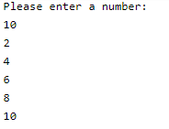

Make sure that you test the functionality of your program against both odd and even end points.